# **Generate Multi Factor Authentication in Avis Direct System**

**Step 1:** Open Avis Direct Application home/login page(https://www.avisdirect.com/home)

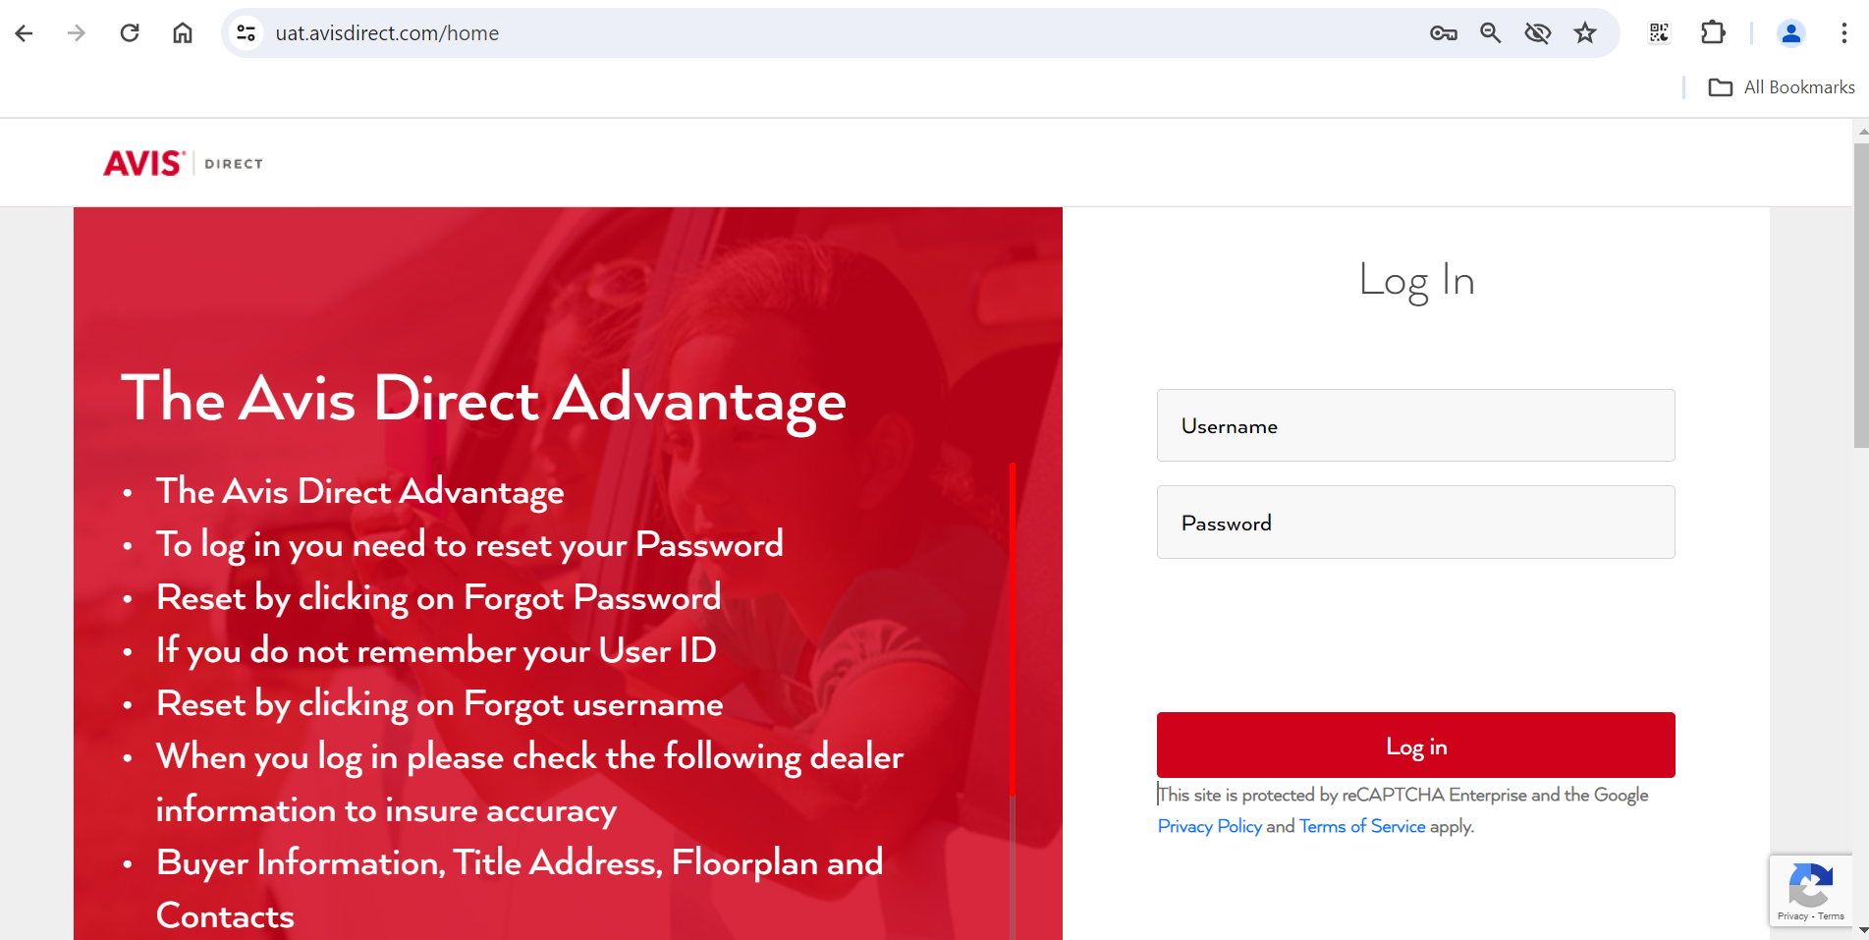

**Step 2:** Enter Username and Password and Click Log in button.

**Step 3:** Once username and password verified successfully, browser automatically lands in **Generate MFA** page.   
  
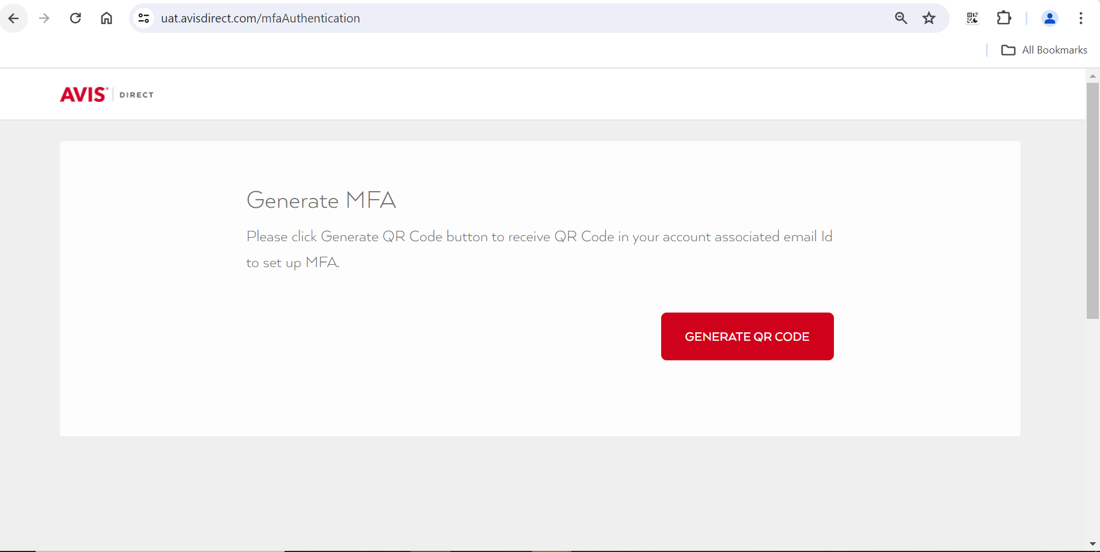

**Step 4:** Click **Generate QR Code** Button

**Step 5:** MFA Generated successfully and QR Code sent to your registered Email Id

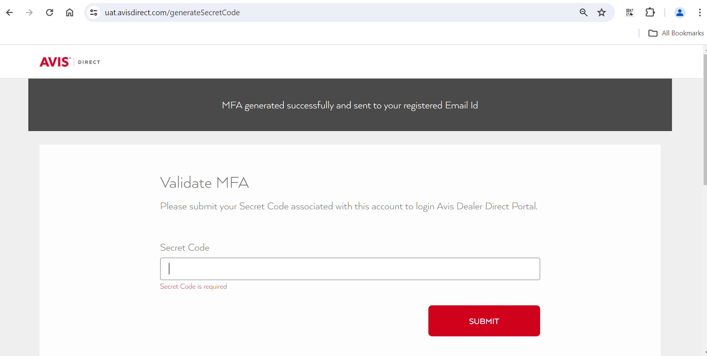

**Step 6:** Received MFA Image Email in my inbox

|  |
| --- |
|  |

**Step 7:** Install **Microsoft Authenticator or Google Authenticator App** in your Mobile from play store

Microsoft Authenticator App - <https://play.google.com/store/apps/details?id=com.azure.authenticator>

Google Authenticator App - <https://play.google.com/store/apps/details?id=com.google.android.apps.authenticator2>

**Step 8:** Open Microsoft Authenticator App in your Mobile

**Step 9:** Click Add Account button or Add Icon (+)

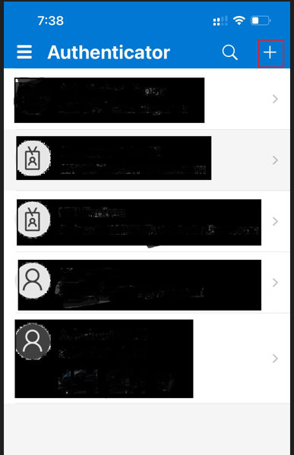

**Step 10:** Choose Other Account Option

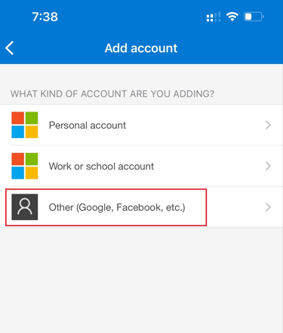

**Step 11:** Open MFA Image Sent via email and scan that QR Code in your Microsoft Authenticator App

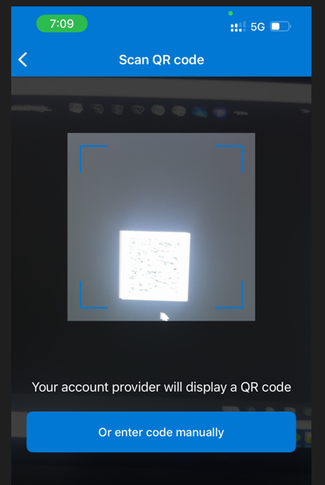

**Step 12:** Once scanned, Avis direct account is added successfully in your mobile app.  
It will list like **Avisdirect-NAM:{your Avis direct application username}**

**Eg: Avisdirect-NAM:avisadmin_june**

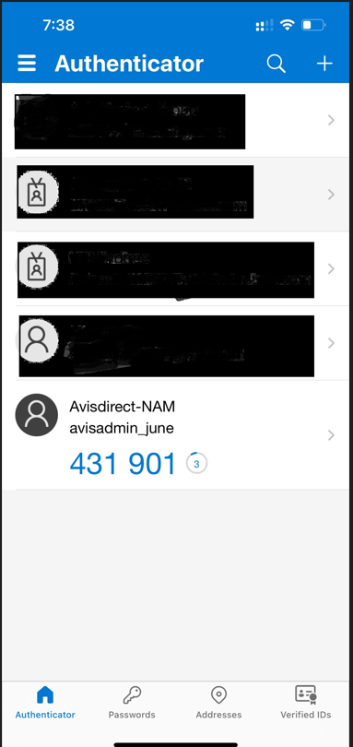

**Step 13:** Now 6-digit Secret Code generated in your Authenticator App

**Step 14:** Open Avis Direct Application home/login page(https://www.avisdirect.com/home). Enter username and password. Click **Log in** button.

**Step 15:** Once username and password verified successfully, browser lands in **Validate MFA** page.

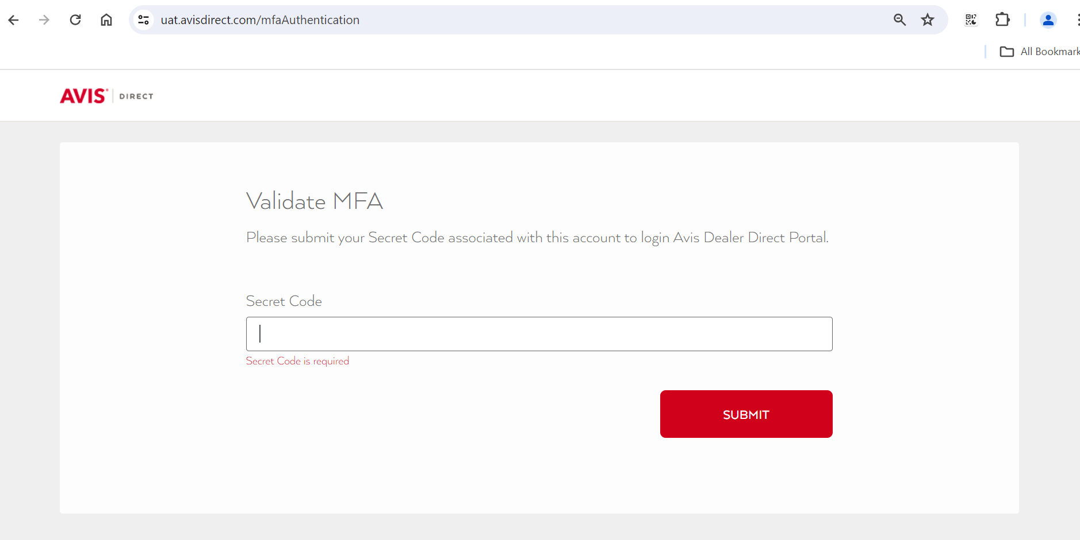

**Step 16:** Enter 6-digit secret code generated in your Authenticator App and click Submit

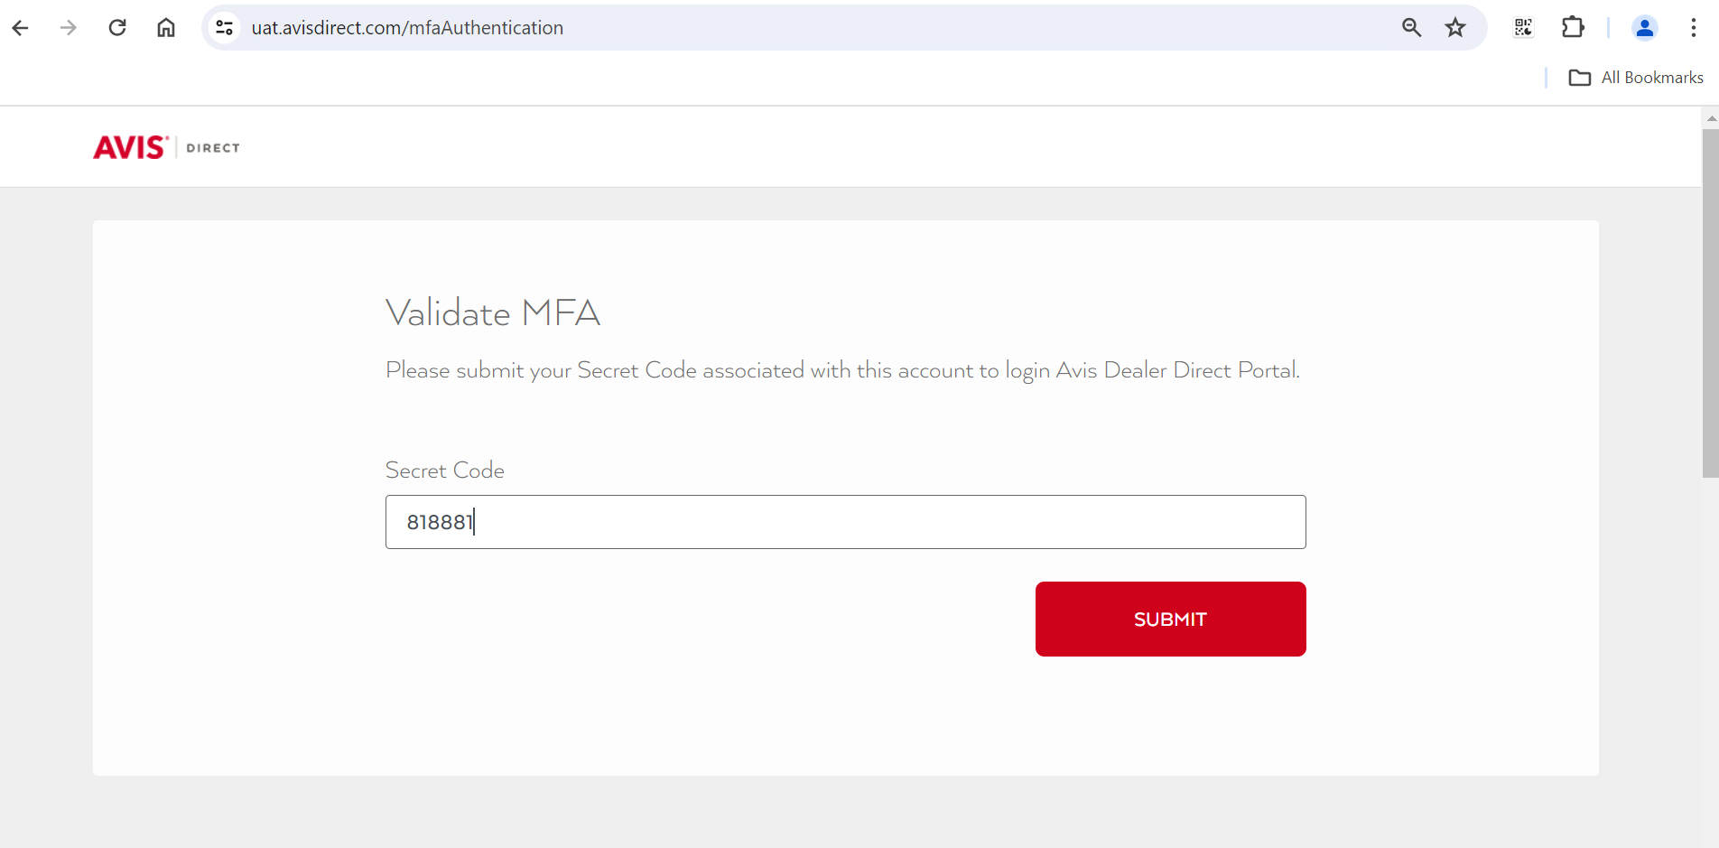

**Step 17:** After the secret code validation, browser will land in the Avis direct Dashboard page

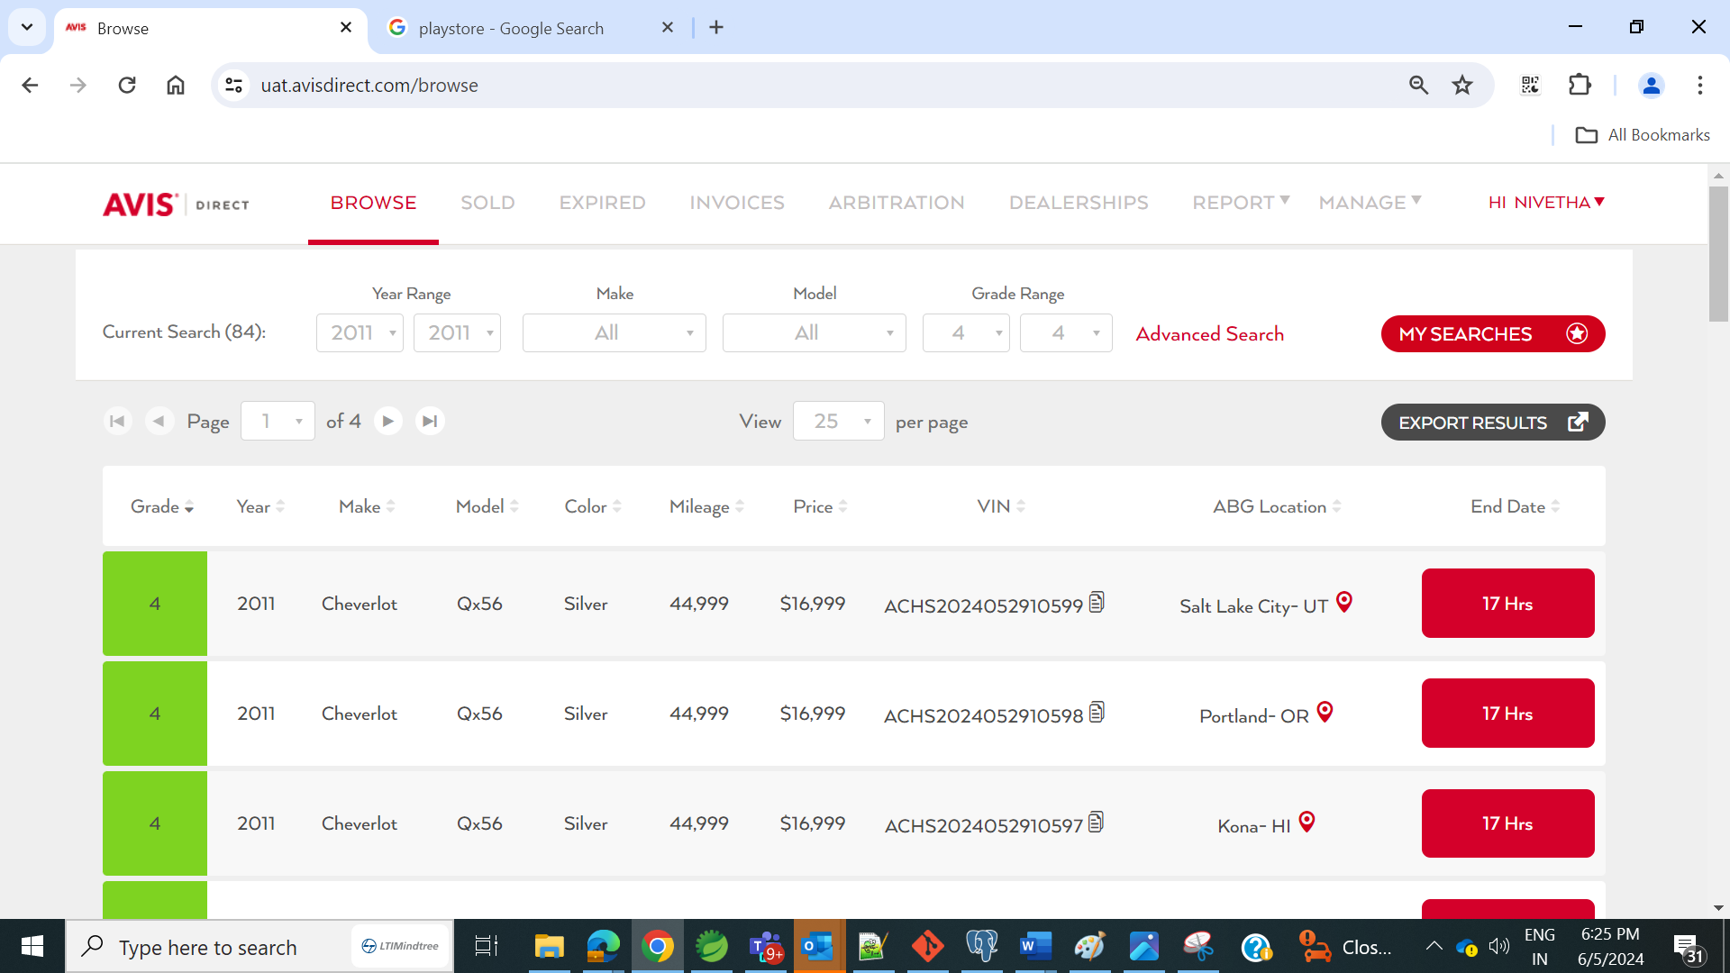

### Reset Multi Factor Authentication(MFA)

In case any Avis direct users (Dealer/Buyers/Arbitration users/Admins) lost their MFA/QR code added mobile, they need to request System admin to reset the MFA.   
Once reset is done by the System admin, the user can generate the new QR Code and add that in their new mobile.